Troop Link Enabling Delivery

If your council offers the ability to turn varieties and delivery on/off later in the sale, you can turn your Troop Link from Shipping/Donation only to allowing Girl Delivery in order to use it for Virtual Booths, Curbsider Pickup orders, etc.


Your council will let you know when this feature is available. When it is, you can login as the parent of the Troop “girl”. Then, proceed to the “Inventory” tab.




On the Inventory tab, scroll to “Girl Scout Delivery Settings” and change the status from “Inactive” to “Active”.

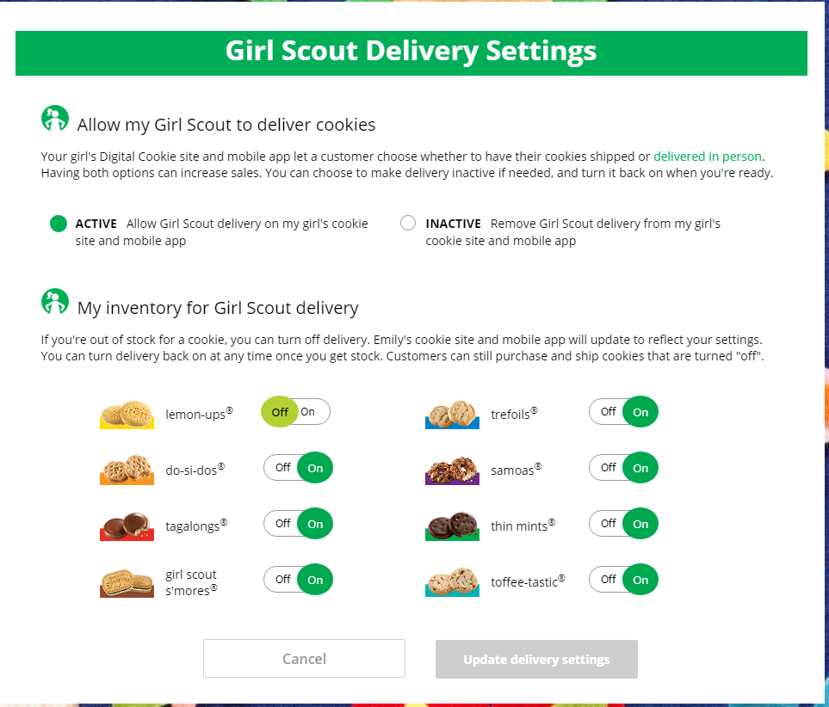

Once you do that, you will see a message letting you know that the site will be removed from the Cookie Finder. If you want to have a delivery option for your troop link, you must approve that change and your troop’s link will now be available for delivery and will be removed from the Cookie Finder if the Finder is active.

If you want your troop’s link to reappear on the cookie finder, you can mark the site to “Inactive” and the link will not have delivery as an option but will be available on the Cookie Finder.

